Rails Reference
See http://bretm.home.comcast.net/rails.html for the most recent version of this document.
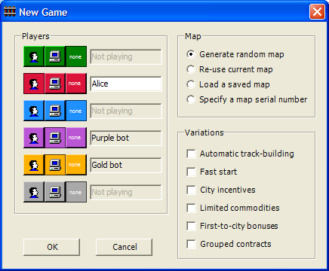
Starting a New Game
When starting the game for the first time, you’ll be presented with the New Game dialog where you can specify the number of human and computer players, which game map to use, and various game options.

In the example to the right, a human player has selected to play red and to play against purple and gold computer players. A randomly-generated map will be used, and no rules options will be used.

Choosing a Route
Once you choose OK on the New Game dialog and the map has been generated, you’ll see a list of available contracts to the right of the map. Each contract depicts a commodity, a destination city, and a payoff amount. If you deliver the indicated commodity to the destination city, you receive the specified amount in payment.

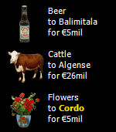
You can hold your mouse over one of the contracts to highlight the destination city and all the sources of the commodity. At the start of the game you probably won’t be able to fulfill a contract more than about €35 or €40 without going into debt. Ideally you would look for a combination of contracts that have destinations close to each other and where the commodities can be obtained near each other so that you can carry both loads in the same trip.

Once you fulfill a contract it is discarded and replaced with a new one. Two additional contracts are discarded as well, and three random new contracts are added to the list. With the standard rules, the two additional deleted contracts are those at the bottom of the list. With the “Grouped contracts” option, the two other contracts in the same group as the fulfilled contract are deleted.

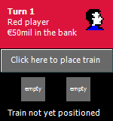Positioning the Train
Once you have decided which contract to fulfill first, place your train at one of the source locations for the commodity displayed on the contract. To position your train, click the train positioning button, and then click on the map on the desired city. If you make a mistake you can choose Undo from the Edit menu and try again.

Once your train is on the map, the train positioning button will be replaced by your train indicator to show the type of engine you have. You can click on the train indicator to upgrade your train.

Picking Up and Delivering Cargo
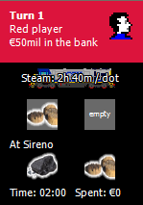When your train is in a city, the city commodity display shows the commodities available for pickup at that city. To load cargo, simply click one of the commodities in the city commodity display directly under the train display. You must have at least one empty freight car in order to load cargo. If all of your freight cars are full, you’ll either need to upgrade your train and add another freight car, or you’ll need to unload unneeded or less desirable cargo. To unload cargo, just click the commodity icon in your train cargo display. See the image to the right for how it would appear after loading cork in Sireno.

Track-Building Costs

€1 Base cost per track segment
€1 Into a mountain milepost
€4 Into an alpine milepost
€2 Into a city or town
€4 Into a major city*
€3 Into a port*
€2 Over a river
€4 Over coastal water or lake

* During the first two turns, players can build into ports and major cities for free. After turn two, they can only build out of major cities to which they are already connected by track. They can always build out of any port but at an additional cost of €3 if they are not already connected to that port by track.

Costs are cumulative. For example, to build over a river into a major city at a mountain milepost would cost €1 (base) + €2 (river) + €4 (major city) + €1 (mountain) = €8.
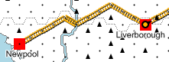
In this example, extending the track from Liverborough to Newpool costs €15. There are 11 track segments, and it costs an extra €2 to cross the river and €3 to enter Newpool.

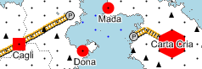In the example to the right, extending the track from Cagli to Carta Cria costs €17. There are 6 track segments. Crossing the mountain milepost costs an additional €1, entering the first port costs an additional €3, leaving the second port costs €3 more, and entering a major city costs €4 more.

Only two players may connect to any given town (circle), and only three players may connect to any given city (square). No player may build more than three track segments into or out of a town or city. There are no such limitations for major cities (hexagons).

Moving the Train
Your train can be moved by right-clicking on the desired destination milepost. The computer will automatically select the fastest route if more than one route is available. Sea mileposts cannot be used as movement destinations. Ferries follow fixed routes across the sea. If the land-based destination requires sea movement, the computer will automatically use the appropriate ferry route.

Different locomotive types travel at different speeds. The time indicator shows how much time has been spent in the current turn. Once the indicator shows 24 or more hours, you cannot perform any more actions that require time. Any time used in excess of 24 hours is taken away from your available time on the following turn.

Train and Ship Movement Speed (per milepost)
Steam locomotive 2h 40m (9 mileposts per day)
Electric locomotive 2h 00m (12 mileposts per day)
Diesel locomotive 1h 36m (15 mileposts per day)
Maglev locomotive 1h 20m (18 mileposts per day)
Ship 6h 00m (4 mileposts per day)

Additional Costs
Loading or unloading cargo at a city 2h 00m per load
Upgrading the locomotive engine 3h 00m plus €20 (per upgrade, up to Maglev)
Adding a freight car 3h 00m plus €20 (per car, up to four total)
Borrowing money 100% of amount of loan (no limits on amount of debt)
Using other players’ track €4 (for remainder of turn, paid to the other player)

Game Controls
Build track Left-click at starting milepost and drag to additional mileposts
Cancel track Backtrack with mouse to cancel one segment, or right-click or Esc to cancel all
Place train Click on the train speed indicator, then click on a milepost
Move train Right-click at destination
Load cargo Left-click the cargo under the city name in the status area
Unload cargo Left-click the cargo under the locomotive in the status area
Upgrade train Click on the train speed indicator
Next player Click anywhere in the turn indicator area
Look at demand Position the mouse over the contract to see source and destination cities
Look at supply Position the mouse over a city to see commodities available there

Additional Menu Options
File menu
- Save map | Adds the current random map to the map gallery to allow it to be selected for play again later
Commands menu
- Discard all contracts | All nine contracts are discarded and replaced with new contracts. There is no limit to the number of times you can do this, but it uses 24 hours. Therefore this option cannot be selected if you have spent any time or money during the current turn.
- Use another player’s track | Permits you to use one or more selected players’ track for the remainder of the current turn. The cost is €4 and is paid to each of the selected players.
Stats menu
- Top commodities | Lists the relative value of each of the commodities available on the current map. The value of the commodity is the average contract payoff value for that commodity. Note that this is the long-term average assuming a sufficiently large number of contracts are generated. Actual contracts are random.
- Player rankings | This command is only available during a human player’s turn while their train is not moving. It shows the relative net worth of each player. This amount includes the player’s cash, the value of the train upgrades, the value of the cargo they are carrying, and a penalty amount based on the amount the player would need to spend to meet the major city connection requirement.
- Win/loss record | Shows a record of all the games played, who won or lost, how many turns the game took, and the game options that were in effect for each game.

Summary of Random Events (may occur at the start of any turn and last one round)

Dock Workers Strike
No loading or unloading cargo within three mileposts of a sea.
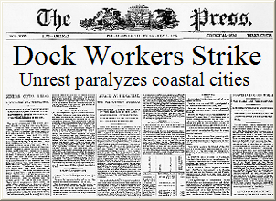 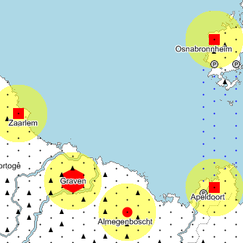
General Strike
No loading or unloading cargo more than three mileposts from a sea.
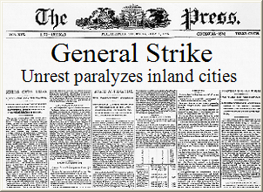 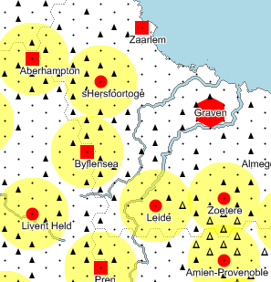
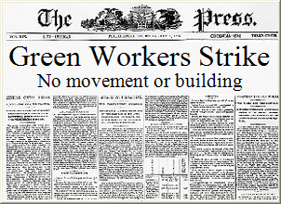
Company Strike
No movement on the current player’s track. Current player may not build track.
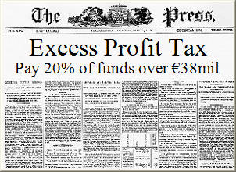
Excess Profit Tax
20% tax on cash in excess of the poorest player’s cash.
Derailment
Players within three mileposts of five randomly selected cities lose a turn and a randomly selected load of cargo.
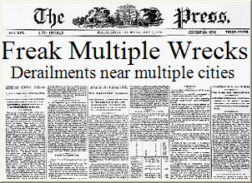 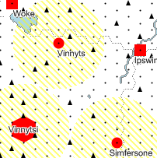
Alpine Snow
Within storm area trains move at half speed, trains cannot move onto alpine mileposts, and track cannot be built.
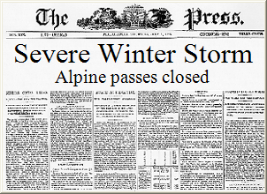 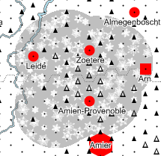
Mountain Snow
Within storm area trains move at half speed, trains cannot move onto alpine or mountain mileposts, and track cannot be built.
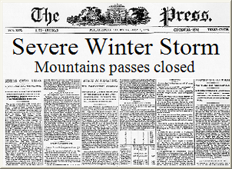 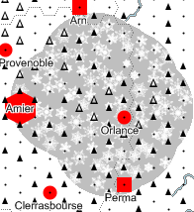
Fog
Within four mileposts of the effected city, trains move at half speed and no track can be built.
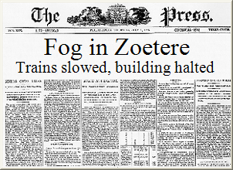 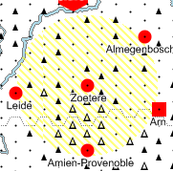
Flood
Track crossing over affected river is destroyed but may be rebuilt. Trains cannot move over affected river.
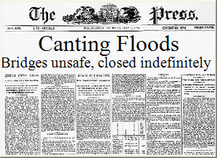 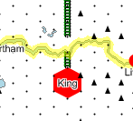
Severe Gale
Ships on selected sea or trains at ports on selected sea lose one turn and one load. Within six mileposts of the sea, trains move at half speed and no track can be built.
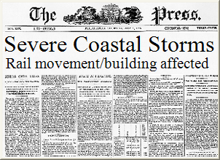 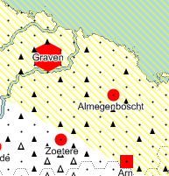
Gale
Within four mileposts of the affected sea, trains move at half speed and no track can be built.
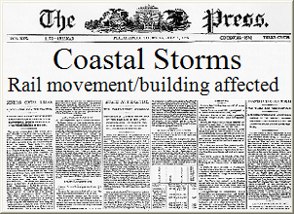 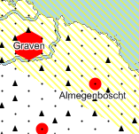

Variations
Automatic track-building: Allows players to click the third mouse button (or the mouse wheel) at a destination to automatically build the cheapest track possible to that destination.
Fast start: Players start with €70 instead of €50 and an electric locomotive instead of steam.
City incentives: Highlighted cities pay 50% bonus. Once bonus is paid, incentive moves to more remote city.
Limited commodities: Finite supply of each commodity. If supply is exhausted, you must wait until another player unloads the commodity before it becomes available again. There is one of each commodity in a 2-player game, two of each in a 3- or 4-player game, and three of each in a 5- or 6-player game.
First-to-city bonuses: The first delivery to each city receives a 50% bonus. Eligible cities are highlighted on the map.
Grouped contracts: Contracts are divided into groups of three. When a contract is fulfilled, all three contracts in the group are discarded instead of the current contract plus the bottom two contracts.
Differences Between Rails and Eurorails®

- In Eurorails trains only move at 9 per turn or 12 per turn. There is no time penalty in Eurorails for picking up or dropping off cargo “just because”.
- Rails allows trains to be upgraded to four freight cars instead of just three. This provides twelve different combinations of engines and cars.
- In Eurorails, track building always follows train movement in a given turn. In Rails, building and movement can be interleaved at will, and you can place and move trains even during the first two turns.
- In Rails, players do not need to start their first turn from a major city.
- Events occur randomly at the start of each players’ turn and last one round. Fulfilling contracts does not invoke random events.
- In Eurorails, nine contracts are divided among three contract cards. When you deliver a cargo, you lose the opportunity to deliver on the other two contracts on the card. Rails can be played with that option, although the default rules are different. You have nine contracts listed from top to bottom. After a contract is fulfilled and removed, the bottom two contracts on the stack are also removed and three new contracts are added to the top. This forces you to choose between contracts in some cases, just as in Eurorails, and it ensures that your unwanted contracts eventually go away.
- The map in Eurorails is a static map of Europe. Rails provides a new map for each game, with new city names modeled after the spelling patterns found in real English, German, French, Italian, Spanish, Polish, Dutch, and Ukrainian city names.
- Since Rails is computerized, the building costs are automatically calculated. The contract sources and destinations are automatically highlighted on the map. If multiple routes are possible for movement, the fastest route is automatically selected. Computer opponents provide a challenge for solitaire players or additional opponents for multiplayer games.
- Trains do not wait at ferry terminals, and land movement rate is not affected by ferry usage. However, time is expended during sea movement.

CSX locomotive graphic copyrighted by Chris Denbow
Eurorails is a registered trademark of Mayfair Games. All Rights Reserved.

